POLICY REGULATING ALCOHOL, DRUGS AND RELATED SUBSTANCES: CANNABIS-SPECIFIC

PREAMBLE
The misuse of substances, including alcohol and drugs, is a national policy priority and focus area of government. In the Company this needs to be clearly addressed through a documented set of principles, guidelines and rules that govern the employer-employee relationship and the workplace context as a whole.
The adverse effects of alcohol, drug and related substance misuse in the workplace include the following:
- Absenteeism
- Accidents and injuries
- Health
- Productivity
- Conflict
- Damage to property
- Liability profile.
As a result of the nature and extent of the Company’s business, values and the various workplaces, a principle “zero-tolerance” approach is adopted. This means that no person shall be allowed onto the premises of the company if there is any trace of alcohol, drugs or related substances. Notwithstanding this, each case will be dealt with on its own merits in the context of the business protocols.
This policy recognises the need for effective and consistent action, while striking a proper balance between work, privacy and concern for the individual. This is vested in the fact that the right to privacy needs to be limited in accordance with the provisions of the Constitution and other laws because when an individual enters into relationships with and engages in relations with other parties outside his or her private sphere, the said individual’s activities then acquire a business and social dimension and the right of privacy in this context becomes subject to limitation.

Therefore -
- The Company is committed to maintaining the highest possible standards of occupational health and safety and considers alcohol, drug and related substance abuse to be disruptive of and detrimental to a safe, healthy and productive working environment.
- The Company views substance abuse and dependency as treatable health problems and accepts that employees who experience such challenges should in certain circumstances be provided with assistance, subject to certain conditions outlined in this policy.
- The Company does not support unjustified intrusion into the private lives of the employees, however, it does expect all employees to report to work in a condition to safely and effectively perform their duties.
- The Company will ensure that the contents of this policy and procedure will be communicated to all employees, unions and management as well as other stakeholders where necessary.
Management has a legal responsibility to ensure that the work environment, its employees and other stakeholders remains safe, healthy and engaged. This includes ensuring that no employees are at the workplace and/or on duty under circumstances where they are under the influence of intoxicating alcohol and/or drugs and/ or related substances nor have traces thereof in their system to the extent that it undermines the company’s policies in this regard. In the context of this policy, this is largely because (for example) cannabis is still classified as a depressant, stimulant, or hallucinogen and therefore a classified “drug”. The use of cannabis in particular has been decriminalised under certain conditions, not legalised unconditionally.
The Company will endeavour to identify the emergence of alcohol, drug or related substance abuse/dependence in an employee by monitoring factors such as:
- Decline in work performance
- Absenteeism (especially over weekend, for weekend workers, and on Fridays and Mondays)
- Sick leave patterns (especially on Fridays and Mondays)
- Accidents at work
- Behavioural changes towards other employees
The Company also recognises that the prevention of drug and alcohol abuse by changed attitudes and a changed culture within the company’s establishment as well as the early detection of such thereof are effective in addressing this.
APPROACH
The Company shall not permit any person who is and/ or who appears to be under the influence of intoxicating alcohol and/ or drugs and/ or similar substances, to enter or remain at the workplace. Furthermore, no person at a workplace shall be under the influence of nor have in his or her possession nor partake of nor offer any other person intoxicating alcohol and/ or drugs and/ or related substances. In the case where a person is taking prescription or other medicines, the Company shall only allow such person to perform duties at the workplace if the side effect of such medicine do not constitute a threat to the health or safety of the person concerned, or other persons at the workplace or to equipment or other assets.
Whilst each case will be addressed on its own merits, in order to give effect to the company’s legal obligations as a key ingredient of this policy, a zero-tolerance approach to being under the influence of intoxicating alcohol and/or drugs and/ or having traces thereof in the employee’s system applies.
Specifically:
- A zero-tolerance of possession and/ or use and/ or cultivation of cannabis where it falls outside of the realm of “private purposes and in a private place” bearing in mind that the workplace is strictly a public place (in addition, dealing in cannabis under any circumstance is illegal)
- Other than provided for differently elsewhere in this policy, testing of employees is considered to be mandatory (this includes planned, random and incident-based testing) in order to monitor the zero-tolerance value system) and
- Awareness and education sessions as well as appropriate support through EAP’s will be undertaken as required
“Mandatory” in respect of testing means that the employee shall be tested in the following instances:
- There being a “reasonable suspicion” of impairment of the employee to do the job and/ or to the extent that the employee holds an actual or potential risk to others or to the assets of the business
- There being a workplace incident and/ or accident that would require such testing
- The employee being required to be randomly tested in respect of establishing whether there are traces of the said substances in his/ her system
- There being an agreement between the employee and the company, either in terms of a disciplinary remedial process and/ or incapacity management process and/ or similar arrangement, that the employee will undergo such tests
“Voluntary” refers to instances where the employee(s) concerned request a test for purposes of employee assistance and/ or as part of a voluntary campaign.
In the context of the importance of applying this policy timeously, consistently and fairly, the company is alive to the fact that drug or alcohol-related conduct and/ or abuse may be either a result of a behavioural problem or an addiction-dependence problem. In the latter instance, in particular, it is recognised that the remedy may lie beyond the ability of the individual to control the situation and that assistance may be required to enable him or her to overcome the problem. The nature, extent and approach in respect of offering potential assistance shall be dependent on the merits of each case, the resources available to the employer and the employee and factors pertaining to the job of the employee and the work environment.
However, in the event that drug or alcohol-abusing/dependent employees unreasonably refuse to be tested, refuse assistance or fail to make reasonable efforts to co-operate with the assistance available to them, the employer may adopt a more robust approach than may have been the case had the employee co-operated.
PRACTICE GUIDELINES
The diagram set out below depicts the approach to be adopted by the Company. It is important that this approach must be read along with and supplemented by other relevant statute and policies including but not limited to:

- The Occupational Health and Safety Act (no. 85 of 1993) and General Safety Regulations
- The Drugs and Drug Trafficking Act (no. 140 of 1992) read with Constitutional Court wording
- The Tobacco products Control Act (no. 83 of 1993) insofar as it defines a public place
- Road Traffic Act (no. 93 of 1996)
- Employment Equity Act (55 of 1998)
- The general substance abuse policy of the Company
- The disciplinary and grievance procedures of the Company
- The incapacity procedures of the Company
- The Gifts and Hospitality policies of the Company
- The employment contract and human resource policies of the Company
- Other pertinent provisions.
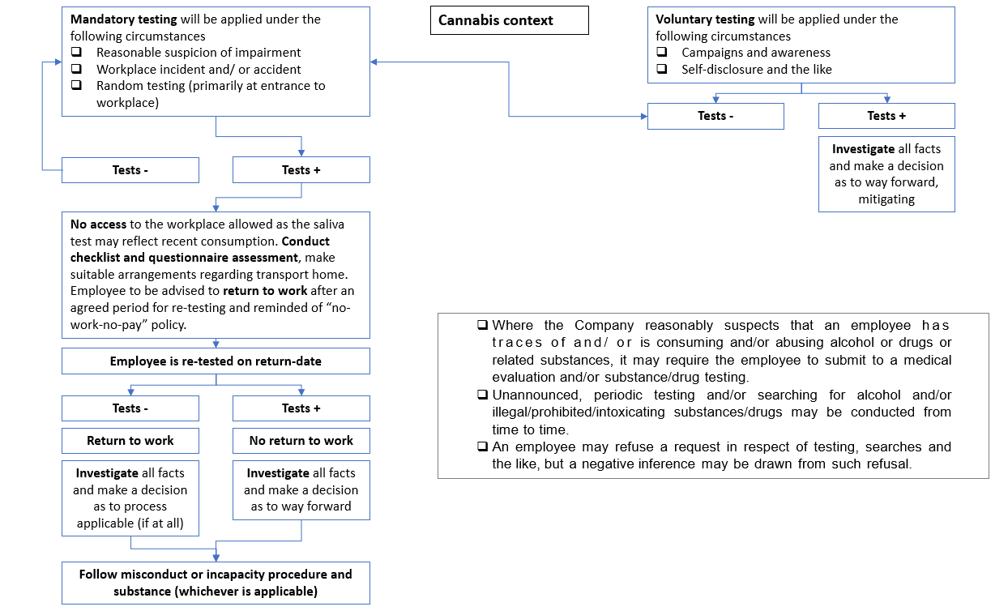
TESTING AND OBSERVATION PROTOCOLS
Testing
The Company will employ appropriate testing protocols and tools to support it in the fair and objective implementation of this policy. Testing includes:
- Blood alcohol test
- Urine alcohol test
- Saliva alcohol test
- Alcohol breathalyser test
Only management, senior staff and designated persons who have been duly authorised shall carry out testing. Where an employee unreasonably refuses to consent to any form of testing, the employee should be advised that the refusal will lead to the conclusion that the employee is under the influence of an intoxicating substance and that, suspension, investigation and possibly disciplinary action is likely to follow.
The type of test to be conducted will be the test that is appropriate in the circumstances. Before an employee may be tested, he or she must be given an explanation as to why the test is needed and informed of the possible consequences of a positive test result.
Searches may be conducted when there is a suspicion and/or situation of disputed possession of substance abuse. No consent shall be necessary for a specific search. Any substance or drug found in the possession of the employee may be confiscated and be submitted in support of appropriate allegations.
Observation
In certain instances, particularly where the employee appears to be impaired at the time, in order to enhance fairness and to take steps to prevent occupational accidents and/ or injuries, observation will be necessary. In this regard the Company will carefully train management, supervisors, human resources personnel, and occupational health and safety committee members, to monitor and record tangible evidence of an employee’s possible impairment. Indicators would include:
- Red eyes
- Slow speech
- Tachycardia
- Sweating
- Anxiety
- Smell of cannabis
- Out-of-character behaviour
- Poor muscle co-ordination
- Delayed reaction times and abilities
- Apathy
- Low energy levels
- Poor motor co-ordination
- Disorientation.
INFROMATION, EDUCATION AND TRAINING
The company is committed to providing employees with information, education and training on all aspects of alcohol and/ or drug use in the workplace during their induction into the Company and through the provision of health and safety updates. Managers and supervisors will be trained in how to identify instances of substance abuse and equipped with the skills and knowledge needed to assist substance-abusing employees and co-workers affected by their behaviour, which will involve the acquisition of effective interviewing techniques and basic counselling skills.
The company will provide drug and alcohol awareness information to all employees including this policy as well as information on the following issues:
- The magnitude and dangers of drug and alcohol abuse
- The health and safety implications of drinking at work
- Where to go for further information and support
- The services available to employees through the EAP
The company will provide a drug and alcohol awareness programme to all employees. This will include:
- Exploring and understanding the effect of alcohol and drugs in the workplace
- Exploring and understanding attitudes to alcohol and drugs
- Exploring and challenging myths surrounding alcohol and drugs
- Identifying alcohol and drug problems in the workplace (signs and symptoms)
- Implementing the alcohol and drug policy
- Interviewing skills
- Putting procedures into practice
- Confidentiality issues
- Identifying and accessing support services
- Referral.
ROLES AND RESPONSIBILITIES
Every employee must take some responsibility in making this policy work. The roles defined below are intended as guidelines.
Role of staff in a managerial or supervisory capacity
- To set a good example to their subordinates and others
- To be familiar with policies and procedures
- To ensure that their subordinates understand the policy and their own responsibilities
- To be alert to, and monitor changes in, work or study performance, attendance, sickness and accident patterns
- To take an objective and non-judgemental approach when counselling or interviewing employees
- To review the progress of employees on a treatment programme
- To refer employees for assistance as appropriate
- To be aware of or seek to identify aspects of the work environment that aggravate or may aggravate problems of substance abuse among employees
- To intervene at the opportunity in cases of actual or suspended substance abuse.
Role of employees
- To find out about the damage caused by alcohol and drug abuse and how such abuse affects workplace relations
- To avoid covering up for or colluding with colleagues who abuse alcohol or drugs
- To encourage colleagues who abuse drugs or alcohol to seek help, especially if they are experiencing problems as a result of this abuse or advise a senior member of staff of the matter
- To seek help if they themselves have problems with substance misuse
- To be familiar with the policy and procedures
Role of the Employment Assistance Programme;
- To provide advice and guidance to employees experiencing problems due to substance misuse
- To provide an impartial and confidential service to employees experiencing problems due to substance misuse, which may include counselling, assessment and referral to other agencies.
- To assist in the education and training of employees on all aspects of substance abuse
- To inform the supervisor(s) of employees undergoing counselling and/or treatment of the progress being made by such employees.
Role of Human Resources Department
- To assist employees experiencing problems due to substance abuse by referring such employees to the EAP, advising on the employer’s disciplinary procedure as it relates to issues of substance abuse, and providing further information where necessary
- To increase the awareness and understanding of all employees regarding matters of substance abuse and to promote the advantages of healthy living
- To facilitate the provision of induction and refresher training on all health-related issues, including the issue of substance abuse in the workplace
- To plan and provide training for those in the managerial of supervisory capacity.
Role of employee representatives
- To take part in discussions about the policy
- To help inform employees about the policy
- To encourage employees experiencing substance abuse problems to seek help voluntarily
- To advise employees of their rights and responsibilities under the policy
- To encourage employee to take part in appropriate educational training programmes
- To represent employee, if requested, in any problem or dispute regarding the application of the policy.

USEFUL TERMS OF REFERENCE
- ‘alcohol or drug abuse’ means the consumption of intoxicating drugs or alcohol by an employee which impairs the performance of the work, or which detrimentally affects his or her performance or ability to do the work and/or the relationships at work, and it includes intoxication or impairment at work
- ‘Allowable levels’ for purposes of this policy are set at 0.00 (zero tolerance)
- ‘alcohol or drug dependence’ means habitual reliance upon or addiction to the consumption of excessive quantities of alcohol or intoxicating drugs, or an inability to limit alcohol or drug consumption to within reasonable limits
- ‘counsellor’ means the person appointed by the parties charged with the responsibility of endeavouring to counsel employees suffering from drug or alcohol abuse and/or dependence
- ‘acceptable work performance’ means to conform to all reasonable requirements and expectations regarding work-related matters
- ‘alcoholism’ means a chronic illness and behaviour disorder, characterised by repeated drinking of alcoholic beverages to an extent that exceeds customary dietary use and/or ordinary compliance with the social drinking customs of the community and/or which interferes with the drinker’s physical or emotional health, interpersonal relations or economic functioning (i.e. job performance)
- ‘alcohol-related problem’ means any employee whose use of alcohol interferes with the efficient and safe performance of assigned job duties is considered to have an alcohol-related problem
- ‘chemical dependency’ means psychological and/or physical dependency from alcohol and/or other drugs
- ‘co-dependent’ means a relative, close friend, or colleague of an alcohol or drug dependent person, whose actions perpetuate or may perpetuate that person’s dependence and thereby retard the recovery process
- ‘dependence’ means a person dependent on a drug or alcohol when it becomes very difficult or even impossible for them to stop taking the drug/alcohol without help after having taken it regularly for some time. Dependence may be physical or psychological or both
- ‘drug’ means any chemical substance that produces physical, mental, emotional or behavioural change in the user
- ‘denial’ means a psychological defence mechanism or range of mechanisms that alcohol or drug related person’s unconsciously or subconsciously establish to protect themselves from the reality of their situation
- ‘fitness for duty’ means to report for work in a sufficiently acceptable physical, psychological and emotional condition to be able to work in an effective, safe manner; such fitness to be determined by approved alcohol and drug testing methods where appropriate in-patient treatment-patients remain in an institution for the duration of the treatment
- ‘intervention’’ means therapeutic and professional guidance given to an employee with alcohol or drug problems in order to help them overcome such problems
- ‘Intoxication’ means the acute effects of excessive amounts of alcohol or other drugs in the body
- ‘prevention’ means appropriate action to counteract the emergency and/or development of unfavourable conditions in a given population/community
- ‘reasonable cause/reasonable suspicion’ means supported by evidence strong enough to establish that the policy violation has probably occurred
- ‘Possession’ refers to the said substance being found on the person or in a locker, vehicle, bag or any container belonging to or being or under control of the person
- ‘prohibited alcohol or drug-related activities’ include the manufacture, transportation, transfer, distribution, sale, purchase, possession, or unauthorised consumption or use of alcohol or other habit-forming drugs
- ‘Prescribed Medication’ is that which is obtained only by means of a medial practitioner’s prescription and under the said practitioner’s treatment
- ‘Reasonable suspicion’ on the part of the Group may arise by virtue of an employee’s appearance or conduct and/or workplace incidents in which the employee is involved and/or where deterioration in the employee’s performance is observed
- ‘registered treatment centres’ mean a licensed health centre or clinic for the treatment of alcohol or drug-dependent individuals, which may be either a private or a public (state) facility
- ‘substance abuse’ means the harmful use of alcohol or drugs by an employee, which has or may have a damaging effect on that employee’s work performance and productivity and his or her relationship with others in the workplace
- ‘substance dependence’ means a clinical diagnosis characterised by specific physiological and behavioural symptoms caused by a pattern of pathological substance use that leads to personal distress or significant impairment in social or occupational functioning
- ‘substance’ includes a solid, liquid, vapour, gas, aerosol or combination of these
- ‘treatment’ means the help given to an alcohol or drug dependent individual by a range of health professionals for the purpose of restoring or improving the quality of life of that individual and his or her spouse or partner, family members friends and other individuals with whom he or she has a close relationship
- ‘under the influence’ means the condition whereby an employee, having consumed an amount of alcohol or drugs that exceeds accepted legal and medical limits, is impaired to the extent that he or she (i) is unable to perform in safe, productive manner and (ii) poses a risk to the health and safety of himself and/or others and to the safety and security of the employer’s property
- ‘well-being’ means a positive state of physical, psychological and emotional wellness
- ‘workplace’ is defined as the premises or place where a person performs work in the course of employment and includes a building, vehicle and vessel

